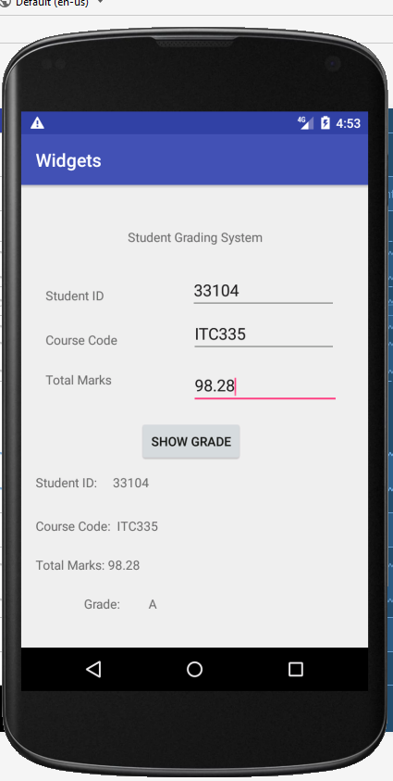

**Java Source Code:**

**package** com.example.test.widgets;  
  
**import** android.support.v7.app.AppCompatActivity;  
**import** android.os.Bundle;  
**import** android.view.View;  
**import** android.widget.EditText;  
**import** android.widget.TextView;  
  
**import** java.util.ArrayList;  
**import** java.util.List;  
  
**public class** MainActivity **extends** AppCompatActivity {  
  
 EditText **stid**;  
 EditText **scode**;  
 EditText **smarck**;  
  
 TextView **eid**;  
 TextView **ecode**;  
 TextView **emark**;  
 TextView **egrd**;  
  
 @Override  
 **protected void** onCreate(Bundle savedInstanceState) {  
 **super**.onCreate(savedInstanceState);  
 setContentView(R.layout.***activity_main***);  
  
 **stid** = findViewById(R.id.***studentid***);  
 **scode** = findViewById(R.id.***studentcode***);  
 **smarck** = findViewById(R.id.***studentmark***);  
  
 **eid** = findViewById(R.id.***textid***);  
 **ecode** = findViewById(R.id.***textcode***);  
 **emark** = findViewById(R.id.***markstexts***);  
 **egrd** = findViewById(R.id.***totlamark***);  
  
  
  
 List<String> list = **new** ArrayList<>();  
  
 }  
  
  
 **public void** showGrades(View view)  
  
  
 {  
 String stdID = **stid**.getText().toString();  
 String stdCODE = **scode**.getText().toString();  
 String stdMARK = **smarck**.getText().toString();  
 **double** stdg = Double.*parseDouble*(stdMARK);  
  
  
 **eid**.setText(**"Student ID: "** + stdID);  
 **ecode**.setText(**"Course Code: "** + stdCODE);  
 **emark**.setText(**"Total Marks: "** + stdMARK);  
 **if**(stdg >= 94 && stdg <= 100 ){  
 **egrd**.setText(**"Grade: A"** );  
 }  
 **else if**(stdg >= 90&& stdg < 94 ){  
 **egrd**.setText(**"Grade: A-"** );  
 }  
 **else if**(stdg >= 87 && stdg < 90 ){  
 **egrd**.setText(**"Grade: B+"** );  
 }  
 **else if**(stdg >= 84 && stdg < 87 ){  
 **egrd**.setText(**"Grade: B"** );  
 }  
 **else if**(stdg >= 80 && stdg < 84 ){  
 **egrd**.setText(**"Grade: B-"** );  
 }  
 **else if**(stdg >= 77 && stdg < 80 ){  
 **egrd**.setText(**"Grade: C+"** );  
 }  
 **else if**(stdg >= 74 && stdg < 77 ){  
 **egrd**.setText(**"Grade: C"** );  
 }  
 **else if**(stdg >= 70 && stdg < 74 ){  
 **egrd**.setText(**"Grade: C-"** );  
 }  
 **else if**(stdg >= 67 && stdg < 70 ){  
 **egrd**.setText(**"Grade: D+"** );  
 }  
 **else if**(stdg >= 60 && stdg < 67 ) {  
 **egrd**.setText(**"Grade: A-"**);  
 }  
 **else egrd**.setText(**"Grade: F"**);  
  
  
  
  
  
 }  
}

XML source code:

*<?***xml version="1.0" encoding="utf-8"***?>*<**android.support.constraint.ConstraintLayout xmlns:android="http://schemas.android.com/apk/res/android"  
 xmlns:app="http://schemas.android.com/apk/res-auto"  
 xmlns:tools="http://schemas.android.com/tools"  
 android:layout_width="match_parent"  
 android:layout_height="match_parent"  
 android:orientation="vertical"  
 tools:context=".MainActivity"  
 tools:layout_editor_absoluteY="25dp"**>  
  
  
 <**EditText  
 android:id="@+id/studentmark"  
 android:layout_width="164dp"  
 android:layout_height="41dp"  
 android:layout_marginBottom="15dp"  
 android:layout_marginEnd="32dp"  
 android:layout_marginRight="32dp"  
 android:ems="10"  
 android:inputType="number|numberDecimal"  
 app:layout_constraintBottom_toTopOf="@+id/btnShow"  
 app:layout_constraintEnd_toEndOf="parent"  
 app:layout_constraintStart_toEndOf="@+id/textView23"  
 app:layout_constraintTop_toBottomOf="@+id/studentcode"** />  
  
 <**TextView  
 android:id="@+id/textView21"  
 android:layout_width="0dp"  
 android:layout_height="27dp"  
 android:layout_marginEnd="15dp"  
 android:layout_marginLeft="27dp"  
 android:layout_marginRight="15dp"  
 android:layout_marginStart="27dp"  
 android:text="Course Code"  
 app:layout_constraintBaseline_toBaselineOf="@+id/studentcode"  
 app:layout_constraintEnd_toStartOf="@+id/studentcode"  
 app:layout_constraintStart_toStartOf="parent"** />  
  
 <**TextView  
 android:id="@+id/textView19"  
 android:layout_width="0dp"  
 android:layout_height="26dp"  
 android:layout_marginBottom="8dp"  
 android:layout_marginEnd="15dp"  
 android:layout_marginLeft="27dp"  
 android:layout_marginRight="15dp"  
 android:layout_marginStart="27dp"  
 android:layout_marginTop="12dp"  
 android:text="Student ID"  
 app:layout_constraintBottom_toTopOf="@+id/studentcode"  
 app:layout_constraintEnd_toStartOf="@+id/studentid"  
 app:layout_constraintStart_toStartOf="parent"  
 app:layout_constraintTop_toTopOf="@+id/studentid"** />  
  
 <**TextView  
 android:id="@+id/textView16"  
 android:layout_width="229dp"  
 android:layout_height="0dp"  
 android:layout_marginBottom="30dp"  
 android:layout_marginTop="45dp"  
 android:gravity="center"  
 android:text="Student Grading System"  
 app:layout_constraintBottom_toTopOf="@+id/studentid"  
 app:layout_constraintEnd_toEndOf="parent"  
 app:layout_constraintHorizontal_bias="0.503"  
 app:layout_constraintStart_toStartOf="parent"  
 app:layout_constraintTop_toTopOf="parent"** />  
  
 <**TextView  
 android:id="@+id/textView23"  
 android:layout_width="0dp"  
 android:layout_height="29dp"  
 android:layout_marginBottom="9dp"  
 android:layout_marginEnd="17dp"  
 android:layout_marginLeft="27dp"  
 android:layout_marginRight="17dp"  
 android:layout_marginStart="27dp"  
 android:layout_marginTop="16dp"  
 android:text="Total Marks"  
 app:layout_constraintBottom_toBottomOf="@+id/studentmark"  
 app:layout_constraintEnd_toStartOf="@+id/studentmark"  
 app:layout_constraintStart_toStartOf="parent"  
 app:layout_constraintTop_toBottomOf="@+id/textView21"** />  
  
 <**EditText  
 android:id="@+id/studentcode"  
 android:layout_width="161dp"  
 android:layout_height="40dp"  
 android:layout_marginBottom="16dp"  
 android:layout_marginEnd="35dp"  
 android:layout_marginRight="35dp"  
 android:ems="10"  
 android:inputType="textCapCharacters"  
 app:layout_constraintBottom_toTopOf="@+id/studentmark"  
 app:layout_constraintEnd_toEndOf="parent"  
 app:layout_constraintStart_toEndOf="@+id/textView21"  
 app:layout_constraintTop_toBottomOf="@+id/studentid"** />  
  
 <**EditText  
 android:id="@+id/studentid"  
 android:layout_width="162dp"  
 android:layout_height="39dp"  
 android:layout_marginBottom="8dp"  
 android:layout_marginEnd="35dp"  
 android:layout_marginRight="35dp"  
 android:ems="10"  
 android:inputType="number"  
 app:layout_constraintBottom_toTopOf="@+id/studentcode"  
 app:layout_constraintEnd_toEndOf="parent"  
 app:layout_constraintStart_toEndOf="@+id/textView19"  
 app:layout_constraintTop_toBottomOf="@+id/textView16"** />  
  
 <**TextView  
 android:id="@+id/textid"  
 android:layout_width="0dp"  
 android:layout_height="0dp"  
 android:layout_marginBottom="23dp"  
 app:layout_constraintBottom_toTopOf="@+id/textcode"  
 app:layout_constraintEnd_toEndOf="@+id/markstexts"  
 app:layout_constraintStart_toStartOf="@+id/textcode"  
 app:layout_constraintTop_toBottomOf="@+id/btnShow"** />  
  
 <**TextView  
 android:id="@+id/textcode"  
 android:layout_width="325dp"  
 android:layout_height="0dp"  
 android:layout_marginBottom="18dp"  
 android:layout_marginLeft="16dp"  
 android:layout_marginStart="16dp"  
 app:layout_constraintBottom_toTopOf="@+id/markstexts"  
 app:layout_constraintStart_toStartOf="parent"  
 app:layout_constraintTop_toBottomOf="@+id/textid"** />  
  
 <**TextView  
 android:id="@+id/totlamark"  
 android:layout_width="218dp"  
 android:layout_height="0dp"  
 android:layout_marginBottom="33dp"  
 app:layout_constraintBottom_toBottomOf="parent"  
 app:layout_constraintEnd_toEndOf="@+id/textcode"  
 app:layout_constraintStart_toStartOf="@+id/textcode"  
 app:layout_constraintTop_toBottomOf="@+id/markstexts"** />  
  
 <**TextView  
 android:id="@+id/markstexts"  
 android:layout_width="0dp"  
 android:layout_height="0dp"  
 android:layout_marginBottom="18dp"  
 app:layout_constraintBottom_toTopOf="@+id/totlamark"  
 app:layout_constraintEnd_toEndOf="@+id/totlamark"  
 app:layout_constraintStart_toStartOf="@+id/textcode"  
 app:layout_constraintTop_toBottomOf="@+id/textcode"** />  
  
 <**Button  
 android:id="@+id/btnShow"  
 android:layout_width="115dp"  
 android:layout_height="wrap_content"  
 android:layout_marginBottom="12dp"  
 android:onClick="showGrades"  
 android:text="Show Grade"  
 app:layout_constraintBottom_toTopOf="@+id/textid"  
 app:layout_constraintEnd_toStartOf="@+id/studentmark"  
 app:layout_constraintStart_toStartOf="@+id/studentmark"  
 app:layout_constraintTop_toBottomOf="@+id/studentmark"** />  
</**android.support.constraint.ConstraintLayout**>